POSITIVE TECHNOLOGY THROUGH MOTION-ACTIVATED STAIRWAY LIGHTS

Joselle Amor Aparicio Quinal (Student)

Student of Computer Engineering, College of Engineering, Architecture and Industrial Design, Bohol Island State University-Main Campus, [joselleamor.quinal@bisu.edu.ph](mailto:joselleamor.quinal@bisu.edu.ph)

MAX ANGELO DAPITILLA PERIN (INSTRUCTOR)

Faculty of Department of Computer Engineering, College of Engineering, Architecture and Industrial Design, Bohol Island State University-Main Campus, [maxangelo.perin@bisu.edu.ph](mailto:maxangelo.perin@bisu.edu.ph)

**Imaginative Abstract:** Human progress has been exponentially exploding over the last decades. Most of the material problems of the past generations have been solved. Poverty, crime, and death due to common colds are consistently decreasing. While the rate of anxiety, depression, and mental health illnesses has all been high. Positive technology is a new term that concerns with bringing a positive impact on well-being through the use of technology. In this design study, the researcher built a Motion-Activated Stairway Lights as a means of integrating positive technology into our everyday environment. The system was accomplished thru the utilization of microcontroller Arduino, ultrasonic sensors and LED strips. The Motion-Activated Stairway Lights beautifies the rather traditional stairways in our buildings. The lights are activated by sensors whenever there is someone using the stairs. The system illuminates the stairs giving it a life like aura. Hypothetically this approach attracts people to use the stairs instead of elevators and escalators. In exchange, this can have an impact not only in physical health but also with mental state.

CCS CONCEPTS • Hardware • Emerging Technologies • Electromechanical Systems • Microelectromechanical Systems

Additional Keywords and Phrases: Arduino, Mental Health, Microprocessor, Positive Technology, Programming, Proximity Sensor, Stairway

ACM Reference Format:

Joselle Amor A. Quinal **MAX ANGELO DAPITILLA PERIN**. 2022. **POSITIVE TECHNOLOGY THROUGH MOTION-ACTIVATED STAIRWAY LIGHTS**. In Research Project Presentation for Bachelor of Science in Computer Engineering 3 in CPE 323 – Microprocessor Systems S.Y. 2021-2022, 2nd Semester, Bohol Island State University-Main Campus, Tagbilaran City, Republic of the Philippines. ACM, New York, NY, USA

1 INTRODUCTION

Technology has been solving problems ever since the term was coined. The only difference is that in the recent years, in addition to solving the basic problems like in food, shelter etc. inventors are also looking into creating positive experiences out of technology. Before, it was always about the disease model, - there are problems and we need to find a solution. This approach has saved us a lot of death and lifted countries out of poverty. One example is the invention of medical equipment that uses software and embedded system in order for it to work. Another is the fast transportation that delivers supplies into the most remote areas. The development of plant varieties that can produce more amount or crops than their native counter parts. These are the example of the problems solved by science/technology in our modern age.

In this paper, the researcher built a Motion-Activated Stairway Lights. This system is an automated system which as long as it is connected to an outlet with electricity will continue performing its task. Monitoring the movement on the stairway and changing the light status in accordance to the monitored data.

2 REVIEW OF RELATED LITERATURE

2.1 Positive Technology

“What is wrong about technology?” is a question that leads us to think about all the negative aspects of technology. Particularly the social media platforms that receives a lot of backlashes. And as well as other questionable inventions that raises questions about ethics and morality. In this paper, rather than that question, we will focus more on the question “What is right about technology.” Which is one of the basis of the term positive technology.

Positive Technology approach—the scientific and applied approach to the use of technology for improving the quality of our personal experience—as a way of framing a suitable object of study in the field of cyberpsychology and human–computer interaction [1]. Simply put it, the utilization of technology as a means of improving the individual’s experiences. This term is from the discipline Positive Psychology which is the scientific study of what makes life most worth living” [4]. With the guiding principle of Positive Psychology, technologies are designed in the best possible way to improve our individual experiences, thus Positive Technology.

2.2 Piano Staircase

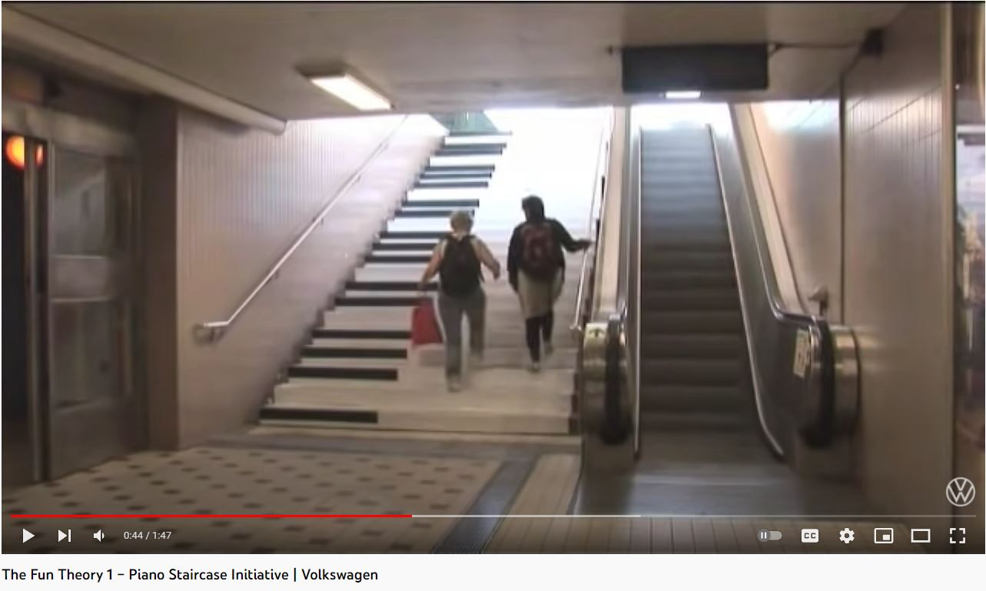

Figure 1. The Fun Theory 1 - Piano Staircase Initiative at Volkswagen Via YouTube <https://www.youtube.com/watch?v=SByymar3bds&ab_channel=Volkswagen>

Piano Staircase [5], a design concept of a musical staircase which was built next to the escalator at the Odenplan subway station in Stockholm, Sweden as we can see in figure 1. People could choose to either use the stairs or the escalator, with the latter being the more popular but unhealthier choice. The designers of the Piano Staircase aimed to change people’s behavior by transforming the stairs into a giant piano keyboard. By applying pressure on each step, the staircase would play a musical note. Through the interactive steps the staircase successfully persuaded and motivated 66% more people to use the stairs instead of the escalator throughout the day they shot the video [5].

This design concept is one of the inspirations for this Stairway lights project. As you can see in figure 1, the stairs were modified in order to look like a piano and sound like a piano. This demonstrates the integration of technology and music and interconnecting the two concepts to produce a system that can be considered a positive technology.

2.3 Arduino, Sensor, and Motion Detection

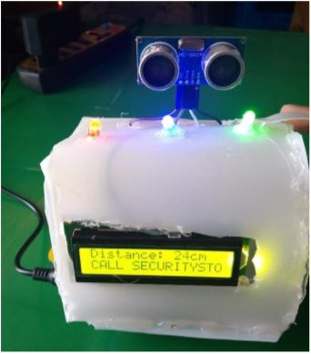

Figure 2. Arduino Uno, Ultrasonic Sensor HC-SR04 Motion Detector with Display of Distance in the LCD project made by Mutinda, Mutava & Kamweru, Paul. (2020).

On a May 05, 2020 a research study was published in International Journal of Engineering research and Technology by Mutanda Mutava Gabriel and Kamweru Paul Kuria from the Department of Physical Sciences of Chuka University. The figure 2 above is the device that they made to measures the distance between the sensor and an object and displays it on an LCD monitor. If the object gets nearer than the limit, the LCD will display a warning message [3]. Their study demonstrated the capability of the Ultrasonic sensor in monitoring movement in the specified area. The Arduino receives these data and converts it into a program which controls the LCD display.

This study has similar concepts with the Motion-Activated Stairway Lights and thus contributed to the knowledge needed to the researcher. Similar concepts were applied but there are major differences. There is no LCD and the data received by the Arduino is used to activate the LED strip.

Understanding Ultrasonic Sensor

* 1. Important Concepts
     1. How HC-SRO4 Ultrasonic Sensors Works.

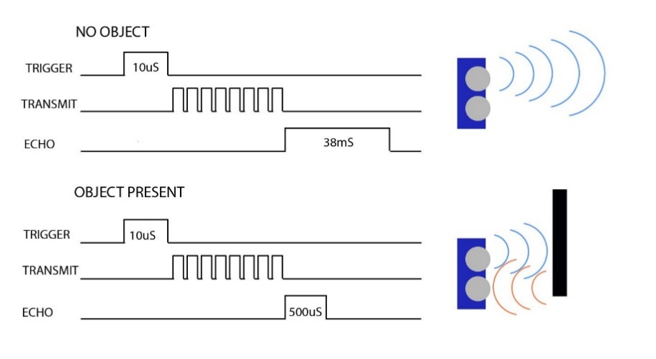

Figure 3. HC-SR04 Ultrasonic Sensor in when there is no object and when there is an object [6].

HS-SRO4 Ultrasonic sensors uses sound waves to detect if there is an object in front of it. Figure 3 above is the demonstration between the difference in the state of the sensor. There are 4 pins on the sensor, VCC, GND, trigger, and echo. VCC and GND are for the power purposes while trigger and echo are for the signal transmission and reception. The trigger pin sends a 5volt, 10uS pulse, 8 ultrasonic 40kHz pulse while the Echo pin outputs a pulse of 150uS to 25 mS pulse width which is used to calculate the distance. The echo pulse will timeout after 38ms if no object is detected [6].

* + 1. Color Mixing of Light.

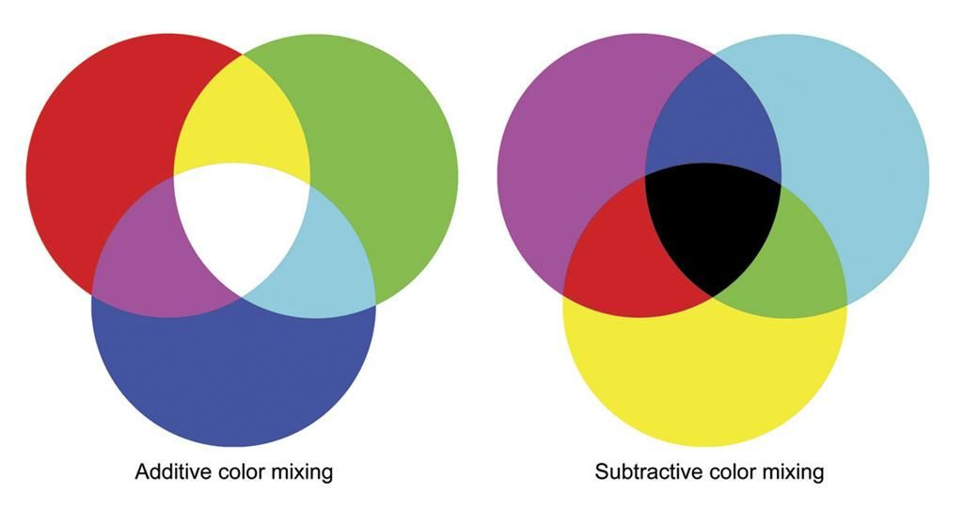

Figure 4. Additive versus Subtractive Color Mixing

There are two main types of color mixing: additive color mixing and subtractive color mixing as shown in figure 4. Additive color mixing is creating a new color by a process that adds one set of wavelengths to another set of wavelengths. Additive color mixing is what happens when lights of different wavelengths are mixed. When we add all of the different wavelengths of sunlight, we see white light rather than many individual colors. It is called additive because all of the wavelengths still reach our eyes. It is the combination of different wavelengths that creates the diversity of colors. Subtractive color mixing is creating a new color by the removal of wavelengths from a light with a broad spectrum of wavelengths. Subtractive color mixing occurs when we mix paints, dyes, or pigments [2]. The LED Strips that are used in this project performs additive color mixing in mixing different colors. The LED strip produces red, blue, and green then uses these values to form new colors.

3 METHODOLOGY

3.1 Preparing the Materials

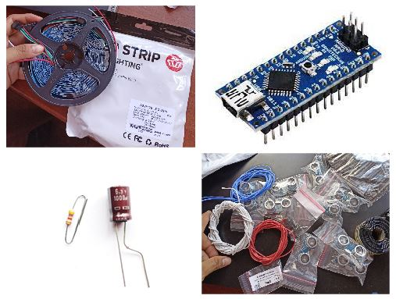

Figure 5. Components used for the project.

In figure 5, the photos of actual components are shown. The LED Strips are two 5-meter bundle individually addressable LED specifically a WS2812B LED Strip. 9 pieces of HC-SR04 Ultrasonic Sensors. Rainbow Dupont Cable and silicone stranded wire for connecting components. A microcontroller Arduino Nano and a resistor and capacitor.

3.2 Schematic Diagram

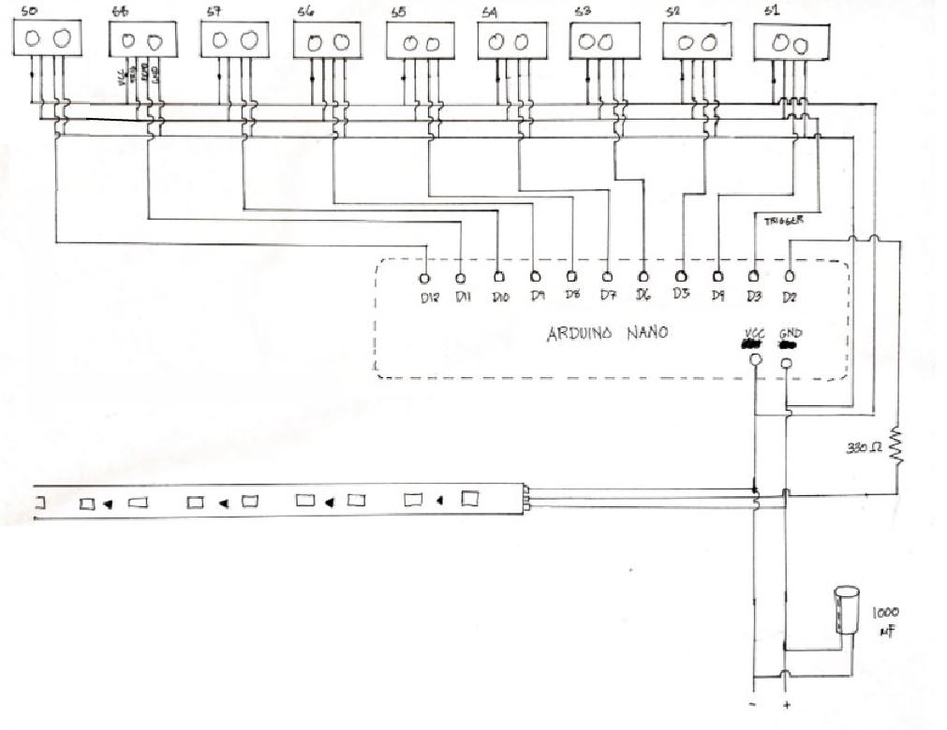

Figure 6. Schematic Diagram

As we can see in figure 6, the sensors’ trigger pins are connected in a series. As a result, we only need 10 pins for the 9 sensors instead of 18. The echo pins are separated because this will be the signal that will indicate the state of a certain step.

For this project to work, individually addressable LEDs must be used. Normal LEDs needs 1pin for one LED which is not practical in this type of project. LED strips can be conceptualized as arrays while normal LED as a carriable. There are various brands and types on the market but what’s important is that it must be programmable in Arduino. The strip used here is a WS2812B LED Strip.

3.3 Prototyping

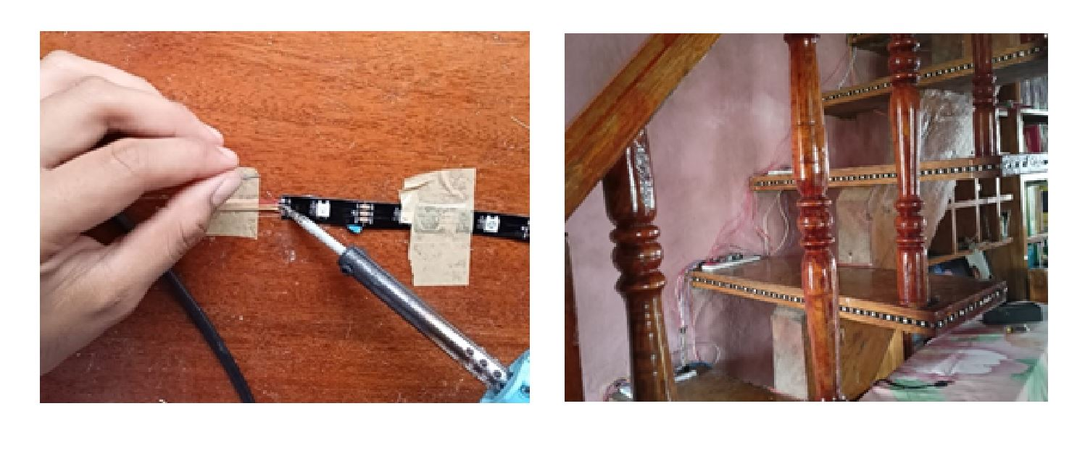

Figure 7. Modifying the LED Strip

In figure 7, the LED Strip was divided into 8 smaller strips each containing 28 individual LEDS. 7 LEDs are on the side profile of the stair step and the other 21 LEDs are on the front. This was achieved by cutting the strip and then linking it with a dopant cable which connects the trigger, VCC, and GND pins. After the modification, the strip was attached to the stairs.

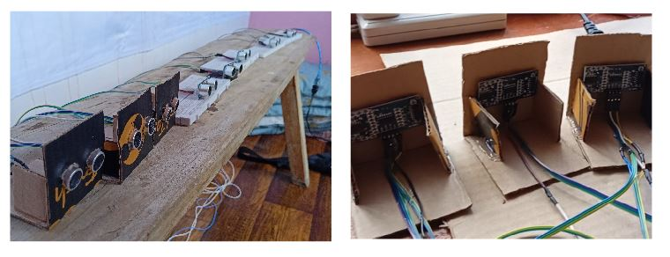

Figure 8. Connecting the Sensors

The sensors require a stand to lie on so the researcher made a casing out of cardboards for that. The connections between the pins were soldered based on the schematic diagram. Since this is only a prototype, some of the sensors were placed on a breadboard. Each of these sensors was placed in each step of the stairway as shown in figure 8.

3.4 Programming

//Code Snippets

#include <FastLED.h>

#include <NewPing.h>

…

void color(int starter, int ender){

EVERY_N_MILLISECONDS( 20 ) {

hue++;

}

EVERY_N_MILLISECONDS(200){

for(int a = starter; a<ender; a++) leds[a] = CHSV( hue, 200, 200);

}

}

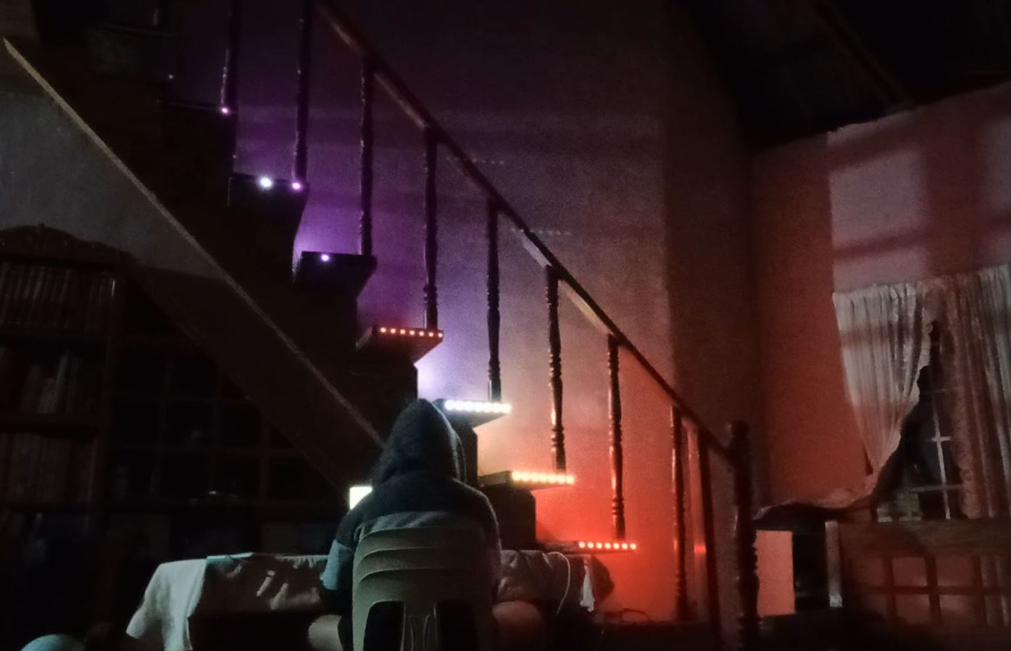

Figure 9. Programming the System with Arduino

In programming the system, 2 external libraries were used. The first one is the FastLED.h library this library is a fast, efficient, easy-to-use Arduino library for programming addressable LED strips and pixels such as WS2810, WS2811, LPD8806, Neopixel and more. The LED strip that was used for this project is supported by the it. The next library is the Newping.h this makes working with the Ultrasonic Sensor easy. With the help of these libraries, programming the system was more manageable. In figure 9, the researcher programs the system while simultaneously testing it.

1. RESULT

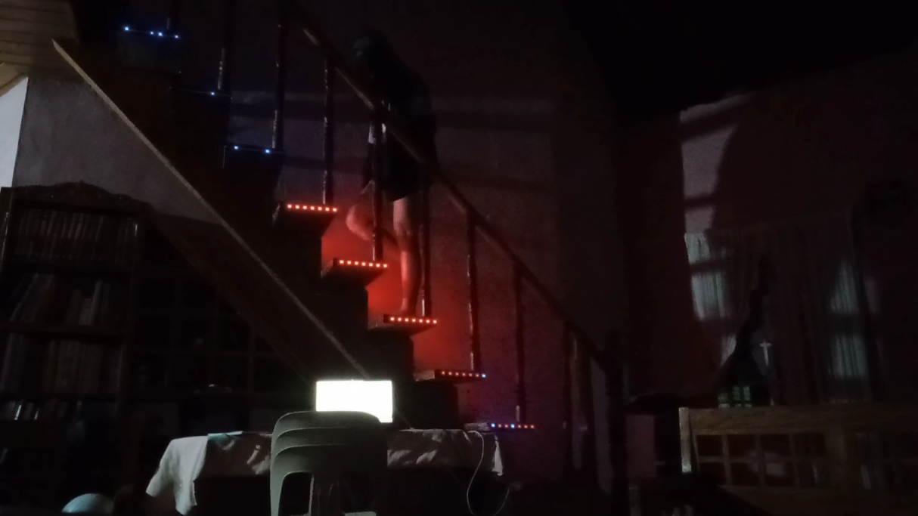

Figure 10. Motion-Activated Stairway Lights

After planning, prototyping and programming the Motion-Activated Stairway Lights was finally completed. Figure 10 is a snapshot of the system when someone is using the stairs. The sensors detected that there is a disturbance and sends signal into the Arduino. The Arduino identifies which sensor it is and lights up the corresponding stair steps.

1. CONCLUSION

The advancement of technology does not limit on solving trivial problems but also extends on the other aspects of human beings. Humans are not purely rational or rigid we have colors and personalities. Therefor it is also important to give attention to our mental state. Integrating positive technology in our everyday life is one way of doing this. In this study, the researcher successfully created a motion-activated stairway light. This system lights up the space, giving a life like structure to the traditional stairs which is indeed an improvement.

ACKNOWLEDGEMENTS

This endeavor would not have been possible without the guidance of our instructor Engr. Max Angelo P. Perin MS.CS. For being patient to his students and imparting vast knowledge in this subject.

I could not have taken this journey without my groupmates who were by my side during the ups and down of this project.

Special thanks to my parents for supporting this project financially, this wouldn’t be possible without them.

Lastly, to our God almighty for giving me the opportunity to live this colorful life. Despite of all the challenges this life brings which includes these academic requirements. God has been good to me and guided me in ways I couldn’t even imagine. With that thank you, and more power.

REFERENCES

<bib id="bib1"><number>[1]</number>Riva, Giuseppe & Baños, Rosa & Botella, Cristina & Wiederhold, Brenda & Gaggioli, Andrea. (2011). Positive Technology: Using Interactive Technologies to Promote Positive Functioning. Cyberpsychology, Behavior, and Social Networking. 15. 69-77. 10.1089/cyber.2011.0139.</bib>

<bib id="bib2"><number>[2]</number>Hong, Zhang & Xiaoshuang, Gao & Obadi, Mohanmmed & Ruirui, Zhao & Jinrui, Tong & Tian, Chunwei & Zhiqiang, Hu. (2016). Research and Implementation of RGB-LED Mixed Light Matching along with Music Playing. International Journal of Grid and Distributed Computing. 9. 111-120. 10.14257/ijgdc.2016.9.4.11.</bib>

<bib id="bib3"><number>[3]</number>Mutinda, Mutava & Kamweru, Paul. (2020). Arduino Uno, Ultrasonic Sensor HC-SR04 Motion Detector with Display of Distance in the LCD. International Journal of Engineering Research and. V9. 10.17577/IJERTV9IS050677.</bib>

<bib id="bib4"><number>[4]</number>Peterson, C. (2008). What is positive psychology, and what is it not? *Psychology Today.* Retrieved from <https://www.psychologytoday.com/us/blog/the-good-life/200805/what-is-positive-psychology-and-what-is-it-not></bib>

<bib id="bib5"><number>[5]</number>Volkswagen. (Oct. 26, 2009). The Fun Theory 1 – Piano Staircase Initiative [Video]. YouTube: <https://www.youtube.com/watch?v=SByymar3bds&ab_channel=Volkswagen> retrieved on June 14, 2022.</bib>

<bib id="bib6"><number>[6]</number> DroneBot Workshop. (Jul 29, 2017). Using the HC-SR04 Ultrasonic Distance Sensor with Arduino – Everything you need to know! [Video]. Youtube: <https://www.youtube.com/watch?v=6F1B_N6LuKw&t=1803s&ab_channel=DroneBotWorkshop> retrieved on June 16, 2022. </bib>

APPENDICES

A1. Source Code

#include <FastLED.h>

#include <NewPing.h>

//For the LED STRIP

#define NUM_LEDS 224

#define LED_PIN 3

//For the Sensors

#define MaxDistance 100

#define trigPin 2

#define echo0 12

#define echo1 4

#define echo2 5

#define echo3 6

#define echo4 7

#define echo5 8

#define echo6 9

#define echo7 10

#define echo8 11

CRGB leds[NUM_LEDS];

NewPing sen0(trigPin, echo0, MaxDistance);

NewPing sen1(trigPin, echo1, MaxDistance);

NewPing sen2(trigPin, echo2, MaxDistance);

NewPing sen3(trigPin, echo3, MaxDistance);

NewPing sen4(trigPin, echo4, MaxDistance);

NewPing sen5(trigPin, echo5, MaxDistance);

NewPing sen6(trigPin, echo6, MaxDistance);

NewPing sen7(trigPin, echo7, MaxDistance);

NewPing sen8(trigPin, echo8, MaxDistance);

float D0,D1,D2,D3,D4,D5,D6,D7,D8;

void setup() {

Serial.begin(9600);

FastLED.addLeds<WS2812B, LED_PIN, GRB>(leds, NUM_LEDS);

FastLED.setBrightness(10);

pinMode(BUZZER, OUTPUT);

}

void loop() {

sense();

EVERY_N_MILLISECONDS(500){

uint16_t sinBeat = beatsin16(30, 0, NUM_LEDS - 1, 0, 0);

leds[sinBeat] = CRGB::Black;

fadeToBlackBy(leds, NUM_LEDS, 10);

}

if(D0 < 57 && D0 > 2)red(0,56);

if(D1 < 57 && D1 > 2)red(28,84);

if(D2 < 57 && D2 > 2)red(56,112);

if(D3 < 57 && D3 > 2)red(84,140);

if(D4 < 57 && D4 > 2)red(112,168);

if(D5 < 57 && D5 > 2)red(140,196);

if(D6 < 57 && D6 > 2)red(168,224);

if(D7 < 57 && D7 > 2)red(196,224);

if(D8 < 57 && D8 > 2)red(196,224);

}

void sense(){

D0 = sen0.ping_cm();

D1 = sen1.ping_cm();

D2 = sen2.ping_cm();

D3 = sen3.ping_cm();

D4 = sen4.ping_cm();

D5 = sen5.ping_cm();

D6 = sen6.ping_cm();

D7 = sen7.ping_cm();

D8 = sen8.ping_cm();

Serial.print("1: "); Serial.print(D1);

Serial.print(" 2: "); Serial.print(D2);

Serial.print(" 3: "); Serial.print(D3);

Serial.print(" 4: "); Serial.print(D4);

Serial.print(" 5: "); Serial.print(D5);

Serial.print(" 6: "); Serial.print(D6);

Serial.print(" 7: "); Serial.print(D7);

Serial.print(" 8: "); Serial.println(D8);

}

void red(int starter, int ender,int tune){

EVERY_N_MILLISECONDS(200){

for(int a = starter; a<ender; a++) leds[a] = CRGB::Red;

}

}